Party Time at San Pietro!

Parties take many shapes and forms and we are happy to meet individual requests. Our Mulino suite is the ideal space to hold your evening entertainment be it a live band, tribute artist or disco, we can assist you in making your party swing.

Decorated in neutral tones with lots of mirror, shimmering wallpaper and Murano crystal chandeliers it provides the perfect glamorous setting for any party

The room is equipped with an impressive in-house lighting and DJ system so that you can play your own personalised playlist without the added expense of a DJ.

In the summertime enjoy the Mulino suites private terrace with outdoor seating, or if it’s too hot don’t worry the room is fully air conditioned.

We have lots of ideas for evening catering and enjoy offering a little something different, we also acknowledge the importance of a budget and give useful advice and recommendations to ensure you get the best possible value for money.

Mulino Suite

(Suitable for 25 - 100 guests)

Room Hire with Catering £170.00

Room Hire without Catering £250.00

Room Hire for less than 30 £200.00
guests with Catering

Room hire is inclusive of private bar, ambient room lighting, disco lighting and virtual DJ. Hire period is from 7:00pm -12:30am with the bar closing at midnight.

For numbers in excess of 100 we recommend exclusive hire of the full restaurant.
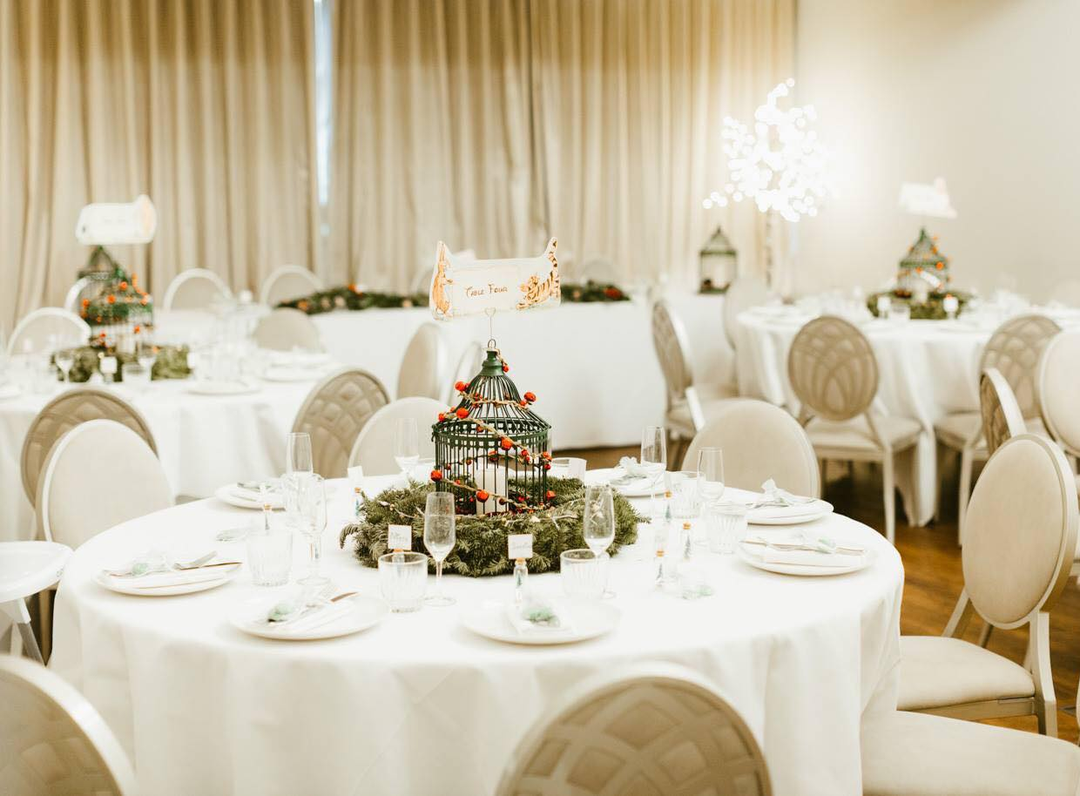
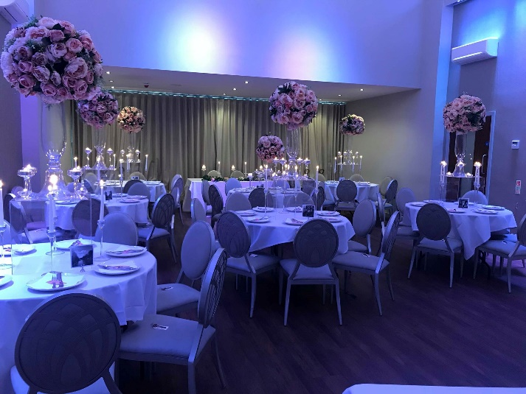

Canapes

- Crostini Selection - £5.50 per person (selection of 3)

  - Cherry tomato and basil
  - Mushroom and truffle
  - Goats cheese and red pepper
  - Pea, mint and feta
  - Gorgonzola, pear and walnut
  - Prosciutto, mozzarella and tomato

- *Selection of 3 Canapés for £6.95 per person

- *Selection of 4 Canapés for £7.95 per person (includes 1 hot canape)

- *Selection of 5 Canapés for £8.95 per person (includes 2 hot canapes)

*At least one option must be vegetarian or vegan

Vegetarian & Vegan Selection (Vg denotes Vegan options)
- Profiterole of goats cheese cream with salted caramel
- Lemon and herb goats cheese mousse, rye bread crisp, preserved lemon
- Mozzarella mousse and roast beetroot crostini
- Toasted pitta, Italian bean hummus, mint, parsley and pine nut pesto
- Bruschetta of tomato and basil (vg)
- Basil and parmesan polenta cake with roast cherry tomato (vg)
- Mushroom and Fontina tartlet (hot)
- Sicilian arancini with mozzarella and truffle (hot)
- Zucchini fritti – lemon and garlic mayonnaise (hot)
- Sicilian chickpea fritter (Panelli) with red pepper salsa (hot) (vg)

Cold Selection
- Prawn cocktail shots
- Smoked salmon blinis
- Smoked mackerel, orange and mascarpone cream, cucumber slices
- Melon and parma ham
- Rolled beef carpaccio with smoked ricotta mousse, rocket
- Ham hock terrine, pineapple salsa
- Rabbit pate, piccalilli, sourdough
- Pressed pork with black pudding and quail egg
- Tuna tartare, avocado puree, rice cracker
- Beetroot cured salmon, mascarpone, pickled beetroot
- Potted beef on sourdough crisp, parsley puree, pickled red onion

Hot Selection
- Slow roast soy and honey pork belly squares with pickled blueberry
- Sicilian arancini with Bolognese and parmesan
- Cod brandade fritter with roasted red pepper puree
- Mini smoked haddock fish cake, pea puree
- Mini baked potato with truffle sour cream and parmesan
- Feta and sesame cigars, honey dressing
- Crostini of goats cheese, chorizo and red pepper
- Pork and chorizo croquet, tomato and chilli jam
- Mini chicken Milanese, red pesto dip
- Crab croquet, avocado puree
- Crispy duck confit, caramelised orange, toasted brioche

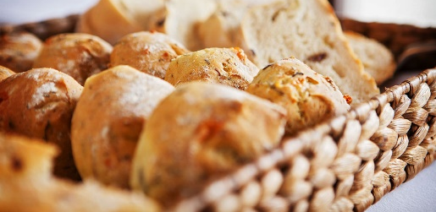
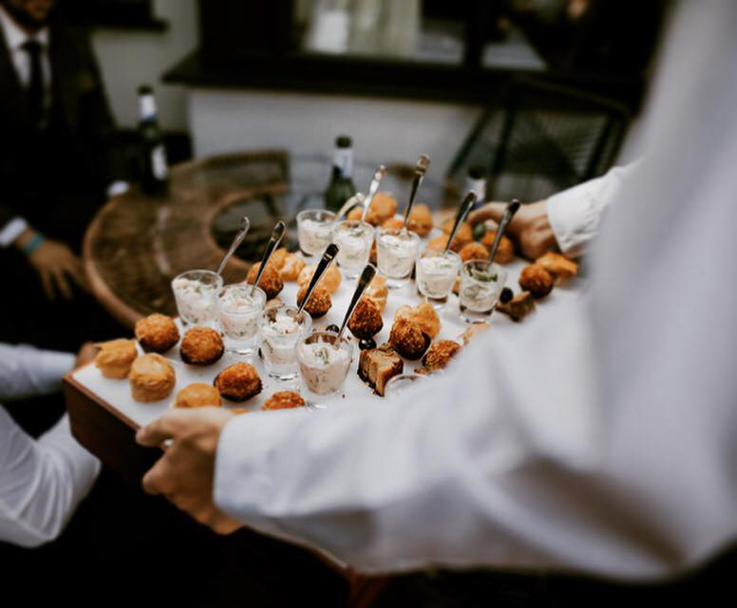

Catering

(Prices based on minimum numbers of 30, prices are per person)

Platter Served Snack Style Options

- Chip Cones - £2.95pp

- Truffle & Parmesan Chip Cones - £3.50pp

- Sausage Baps - £4.95pp

- Hog Roast in a Bun - £7.50pp
Hand carved pork, crackling, homemade apple sauce and stuffing in a bap

- Sicilian Pizzas - £6.95pp
Your choice of four toppings, based on half a pizza per person.

- Margherita
- Mediterranean Vegetable
- Pepperoni
- Chicken & Pesto
- Chicken & Sweetcorn
- Chicken & Mushroom
- Goats Cheese & Red Pepper
- Ham & Mushroom
- Ham & Pineapple
- Mushroom
- Garlic Bread
- Cheesy Garlic Bread
- Tomato Garlic Bread

Formal Buffet Options

- Slow Roasted Lincolnshire Pork Shoulder Buffet - £13.50pp
Accompanied by apple sauce, stuffing, roast potatoes, bread and mixed green salad

- Hot Pasta Buffet - from £10.95pp
(Minimum of 30 people)
Served with mixed green salad, homemade breads with olive oil and balsamic vinegar along with your choice of 3 from the following:

- Traditional pork & beef lasagne
- Pasta Bosciola
- Pasta with pancetta, cream and parmesan
- Lincolnshire sausage ragu with tomato, red pepper, chilli and black olive
- Salmon, prawn and pea pasta
- Handmade lobster ravioli (£3.50 pp supplement)
- Handmade mushroom ravioli (v) (£1.50pp supplement)
- Spinach and ricotta cannelloni (v)
- Spicy tomato and Mediterranean vegetable pasta (v)
- Mushroom and truffle penne with spinach leaves and pine nuts (v)

- Cold Fork Buffet - from £9.95pp
(Minimum of 20 people)
Your choice of 5 from the following selection:

- A selection of homemade sandwiches
- Goats cheese, red pepper and tomato tart
- Insalata Caprese – mozzarella cheese with tomatoes and basil
- Mediterranean pasta salad
- Greek salad
- Cous cous with roasted vegetables
- Potato salad with spring onions, chives and mayonnaise
- Selection of crudité with humous
- Mixed leaf salad, pine nuts and parmesan
- French beans and broccoli with chilli and almonds
- Freshly baked bread, olive oil and balsamic vinegar
- Italian antipasti (£2.00pp supplement)

- Add an extra item for £2.00pp

- Fancy something sweet? Why not add dessert for an additional £5.50 per person

- Chocolate and hazelnut brownie cake. mascarpone cream
- Banoffee pie
- Classic tiramisu
- White chocolate and Sicilian lemon cheesecake
- Warm blackberry frangipan (fruit can be changed subject to season)
- Profiteroles with vanilla cream and chocolate sauce
- Meringues, fresh fruit and whipped cream

- Add whipped cream and fresh fruit for £2.95 per person

- Hot Mediterranean Buffet - from £22.95pp (Minimum of 30 people)

Choose two from the following meat selection:

- Slow roast lamb with garlic, rosemary and mint dressing
- Slow cooked barbecue beef brisket
- Slow roast pork with sage and garlic
- Chicken with a mushroom and cream sauce
- Chicken with prosciutto, Fontina cheese and a cream sauce
- Baked salmon with a crème fraiche and dill dressing (£2.00 per person supplement)
- Spicy Italian meatballs in tomato sauce
- Italian sausage and borlotti bean casserole with red pepper and black olive

Choose one from the following pasta and vegetarian selection:

- Aubergine parmigiana (v)
- Mushroom ravioli (v)
- Spinach and ricotta filled cannelloni (v)
- Penne bosciola - Chicken, pancetta, peas and mushrooms in parmesan cream sauce
- Red pepper and gorgonzola risotto
- Traditional pork and beef lasagne
- Sicilian aubergine stew(vg)
- ‘No Meat’ Balls - Chickpea and pine nut balls in a spicy tomato sauce (vg)
- Mediterranean vegetable and tomato penne

Served with homemade bread, olive oil and balsamic vinegar and your choice of four from the following selection:

- Insalata caprese – Mozzarella cheese with tomatoes and basil
- Mixed green leaf salad, parmesan and pine nuts
- Cous cous with roasted vegetables
- Potato salad with spring onions, chives and mayonnaise
- Pasta salad with mushrooms, sweetcorn and peas in a basil mayonnaise
- Italian antipasti – Salami, prosciutto, Mortadella, Italian pickles (£2.00 per person supplement)
- French beans and broccoli with almonds and chilli
- Hot roast potatoes with rosemary and garlic
- Add French fries to any of our buffets for just £2.00 per person

- Fancy something sweet? Why not add dessert for an additional £5.50 per person

- Chocolate and hazelnut brownie cake. mascarpone cream
- Banoffee pie
- Classic tiramisu
- White chocolate and Sicilian lemon cheesecake
- Warm blackberry frangipan (fruit can be changed subject to season)
- Profiteroles with vanilla cream and chocolate sauce
- Meringues, fresh fruit and whipped cream

- Add whipped cream and fresh fruit for £2.95 per person

Festa Siciliana

Party Italian Style with our Festa Siciliana package – complete with Italian style decorations, arrival drink, canapes, hot 2 course buffet and even wine!

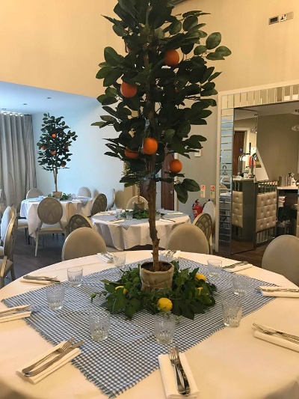
Minimum numbers 30

Includes:

- Private use of our Mulino Suite complete with virtual DJ, private bar service and ambient lighting – no additional room hire to pay
- Complimentary Sicilian themed decoration with olive, lemon and orange tree centrepieces
- Room set with round tables seating up to 8 with white table linen and napkins, gift table and cake table if required
- Aperol or Limoncello spritz on arrival
- A selection of arancini and crostini from our list (2 per person)
- 2 Course hot Sicilian Buffet (please see menu below)

£35.00 pp

- Add half a bottle of Sicilian wine per person for an
additional £10.95pp
- Add a prosecco toast for £5.00pp
- Upgrade to Prosecco and Peroni arrival drinks £2.00pp

Buffet Menu

- Please choose one from the following:
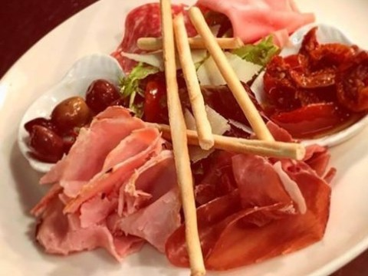
- Chicken Cacciatore
- Chicken Cotoletta with Sicilian Pesto
- Please choose one from the following:
- Pasta alla Norma (with aubergine, tomato, ricotta, pine nuts and basil)
- Pasta Isoli Aeoli (with tomatoes, black olives, capers and pine nuts)

- Sicilian Meatballs in spicy tomato sauce
- Roast potatoes in garlic and rosemary
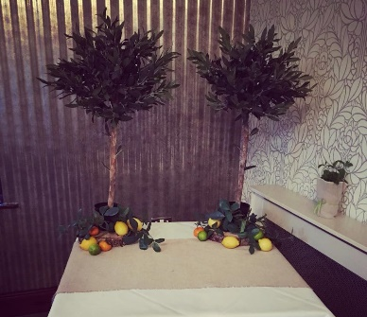
- Tomato red onion and basil salad
- Mixed green salad with parmesan, pine nuts and balsamic dressing
- Homemade breads

Dessert

Please choose one from the following:

- Sicilian lemon and ricotta cheesecake, limoncello cream
- Classic tiramisu

Terms and Conditions

Date: ……………………………………

Between: San Pietro Restaurant with Rooms
11 High Street East
Scunthorpe, DN15 6UH
North Lincolnshire

And: ……………………………………………………

For: ……………………………………………………

Terms and Conditions: The small print as per your signed booking form.

If you have any questions, please feel free to speak to a member of the team before signing.

Therefore, the parties agree as follows:

1) DESCRIPTION OF SERVICES:

(a) San Pietro do not accept responsibility or liability in respect of loss or damage to equipment, vehicles, or personal affects belonging to the hirer or their guests during the period of hire or when left overnight.

(b) The event organiser ………………………………. will be responsible for making good any damage which may have been done to the premises, furniture, flooring or grounds by persons attending the function. A £250.00 damage waiver will be held against a credit or debit card on the morning of the event, which will be released within 7 days, if no damage occurs. Please be mindful that any items hired for use at your event, if damaged or stolen, will be replaced with your damage waiver.

(c) The bar will cease trading at 12:00am and music will be turned off by 12:30am. All guests are required to vacate the premises by 12:45am.

(d) Smoking is prohibited in all indoor areas on the venue, this includes use of electronic cigarettes. A smoking area will be made available with ash trays for proper disposal. The supply of illegal substances will not be tolerated: breach of these terms will result in the forfeit of the damage waiver.

(e) Our insurance only offers cover for the services we provide, all outside services such as entertainers MUST produce copies of their public liability insurance certificate 2 weeks prior to the event. All electrical equipment brought onto the premises MUST hold current P.A.T test certificates, failure to provide these documents the entertainer will be refused to right to set-up. Entertainers are required to liaise with management regarding the use of specialist equipment, power sources etc. Please note should we not hear from the entertainer we may not be able to guarantee any of the above mentioned.

(f) Strictly no outside catering is allowed with the exception of the celebration cake and sweet carts, no other food or drink may be brought onto the premises by the event organiser or their guests, except by prior arrangement with management.

(g) Alcohol must NOT be brought onto the premises unless prior arrangement with management has been agreed in writing. In the event that any alcohol is brought or consumed onsite that has not been authorised or purchased from the bar, the damage waiver will automatically be forfeited, and the guest(s) involved will be asked to leave the venue.

(h) The management reserves the right to refuse admittance or service to any person or persons considered to be intoxicated. The management also reserves the right to remove from the premises any person or persons who display aggressive behaviour towards any member of staff or another member of the public.

2) PAYMENTS FOR SERVICES:

The event organiser agrees to pay an initial non-refundable deposit equalling the value of the room hire to secure the date.

After the initial meeting a pro forma invoice will be issued detailing all the anticipated costs for your event:

Then payments equivalent to: Must be paid:
100% of the total booking value 2 weeks before

Payments may be made via (cash, credit/debit card or bank transfer) – and all additional fees or unforeseen extra costs agreed on the day must be settled on the day with a debit/credit card or cash.

Please note: The remaining balance is calculated on the final numbers supplied by you 2 weeks before, any date transfers may incur an administration fee and cancellations must be made in writing, or the full payment for the venue will be required when due. See section 3 and 4 for further information.

3) DATE CHANGES:

In the event that the organiser is forced to change the date of the event every effort will be made by San Pietro to transfer reservations to the new date. The organiser agrees that in the event of a date change any expenses including but not limited to deposits and fees that are non-refundable and non-transferable are the sole responsibility of the wedding couple. There may also be additional charges above and beyond those set forth in paragraph 2 above. The organiser further understands that last minute changes can impact the quality of the event and that San Pietro is not responsible for these compromises in quality.

4) CANCELLATIONS:

We advise guests to take out insurance against cancellations. Your booking forms a contract in law and cancellations will be charged for at the following rates:

From 6 months prior to the event 25% of the total booking value
From 12 weeks prior to the event 50% of the total booking value
Between 12 and 2 weeks prior to the event 75% of the total booking value
Less than 2 weeks prior to the event 100% of the booking value

In the event of a cancellation all payments made to date are forfeited and any release from these terms will be at the absolute discretion of the business owner.

COULD SAN PIETRO CANCEL MY BOOKING?

We reserve the right to cancel any event which forfeits on the agreed payment plan.

In the unlikely event that San Pietro has to cancel your booking all advance payments will be refunded. There will be an administration charge of 2.5 % for credit card payments, payments by debit card, cash and BACS are free of charge.

However, San Pietro will not accept liability toward any outside contractors/suppliers employed. Cancellation will only occur if any of the venue is closed or unavailable due to events beyond our control but not limited to: war, strikes, fires, floods, acts of god, governmental restrictions, power failures, or damage or destruction of any part of the venue. Cancellation for the afore stated reasons shall not be deemed a breach of this agreement.

5) ACCOMMODATIONS:

Please note we cannot provisionally hold rooms for friends and family, these are to be booked directly through the reception team with debit/credit card details to confirm the reservation and application of a 10% discount will be applied. Should rooms be booked online or through any online booking agent such as Booking.com, Expedia or Hotels.com, the discount will not be offered.

6) AMMENDMENT OF GUEST NUMBERS:

In the event of numbers increasing there will be an additional charge per person based on the costs detailed in the brochure.

In the event of a cancellation or reduction in numbers no refunds after the 14-day final payment deadline will be given.

7) ENTIRE AGREEMENT:

This agreement contains the entire agreement of both parties only and there are no other promises or conditions in any other agreement whether oral or written. This agreement supersedes any prior written or oral agreements between the parties – any oral agreements must be made in writing and agreed with the managing director within 7 days of discussion to confirm.

Sign: __________________________________________________

Print: __________________________________________________

Date: __________________________________________________

